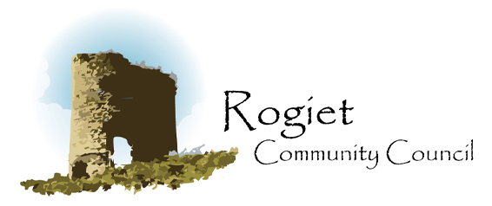

Rogiet Community Council Training Plan 2024

Rogiet Community Council’s training plan is designed to set out requirements for the provision of training for Councillors and employees. The plan needs to ensure that training and development can be carried out in a proportionate way, considering factors such as the activities undertaken by the council and the current expertise and experience of members and employees. The plan also needs to identify areas for further training and development and consider any new challenges and opportunities that may occur or that the council may wish to explore.

- Councillors and employees need to be encouraged to undertake the appropriate training and development opportunities.

- An annual training budget should be considered and agreed.

- An annual assessment should be carried out to Identify individual training needs and opportunities for each Councillor and all employed staff.

- When a training need is either identified or a Councillor or employee requests specific training, the council should consider the most effective way in which the training can be sourced, the cost, and whether others within the council may benefit from the training.

- A regular review of any training undertaken, including a review of the training plan itself, will be required to ensure that the training meets any needs that subsequently arise, such as (but not limited to) :-

Legislative requirements e.g First Aid, Health and Safety, Employment Law
Changes in legislation
Changes in systems or introduction of new equipment
New or revised qualifications become available.
New working methods and practices
Complaints to the council

Training Provision

Internally
Using in-house expertise and knowledge. This may include general computer training, training on specific work procedures/processes or practices within RCC.

Partnerships
The council has links with other partners where training can be sourced, such as through Monmouthshire County Council, One Voice Wales, Gavo (Gwent Association of Voluntary Organisations), Planning Aid Wales and via other community and town councils.

External Training Providers
Various

Professional Bodies
Training towards a professional qualification will usually be sourced through a professional body.

Types of training available

- Face to face courses

- Webinars

- Online courses

- Conferences

- Training days

- In-house training

- Mentoring/coaching

- Provision of relevant books and materials

Training and Development for Councillors

All councillors should have sufficient skills and understanding in the following areas: -

- Basic induction for Councillors

- The Code of Conduct for members of local authorities in Wales

- Standing Orders familiarisation

- Financial regulations familiarisation

The above basics could be considered as Stage 1 in the Training plan with the aim that all Councillors should have completed this stage as soon as possible after joining the Community Council.

Stage 2
Stage 2 training will be more specific for the individual, depending on their existing skills and their roles within the council. Or skills and knowledge they may need when acting as a representative of the council to external organisations.

One Voice Wales offer a variety of training courses which Councillors can undertake. These are quite specific and currently include the following modules: -

The Council as an Employer
Managing your Staff
Health and Safety
Equality and Diversity
The Council Meeting
Understanding the Law
Introduction to Community Engagement
Community Engagement part II (Tools and Techniques)
Chairing Skills
Community Emergency Planning
Community/Place Planning
Information Management
Use of IT, Websites and social media
Making effective Grant Applications
Devolution of Services/Community Asset Transfer

